##### <Store Owner> View Request List

Use Case Diagram

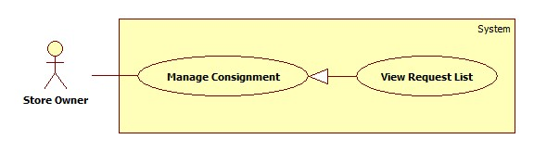

Figure 3: 1.1.1.2. <Store Owner> View Request List

Use Case Specification

|  |  |  |  |
| --- | --- | --- | --- |
| **USE CASE – View Request List** | | | |
| **Use Case No.** | Click here to enter text. | Use Case Version | 2.0 |
| **Use Case Name** | View Request List | | |
| **Author** | PhucTQ | | |
| **Date** | May 29, 2015 | Priority | High |
| **Actor**:   * Store Owner.   **Summary**:   * Show list of consignment request for current store.   **Goal**:   * Store Owner view list of consignment request.   **Triggers**:   * Store Owner asks the system to show request list   **Preconditions**:   * Store Owner has logged onto the system.   **Post Conditions**:   * **Success**: List of consignment request is shown. * **Fail**: List of consignment request is not shown.   **Main Success Scenario**:   |  |  |  | | --- | --- | --- | | Step | Actor Action | System Response | | 1 | Store Owner asks the system to show request list. | Show consignment request list include following information:   * Product Name * Request Date * Consign Price * Transfer Date * Action   [Exception 1] |   **Exceptions**:   |  |  |  | | --- | --- | --- | | No | Actor Action | System Response | | 1 | Store doesn’t has any consignment request. | Show message “There is no consignment’. |   **Relationships**:   * Included Use-case: N/A. * Extended Use-case: N/A. * Including Use-case: N/A. * Extending Use-case: View Request Detail.   **Business Rules**:   * Filter bar shall be shown on the top to help Store Owner find consignment faster. * List are sorted by on request date in reverse chronological order. The most recent request appears first in the list, while the oldest one appears last. * The list shall help Store Owner indicate that which consignment has been viewed and which one has not been viewed. * The list shall help Store Owner indicate that which consignment product was evaluated and which one was not. * The list shall track Store Owner action for each consignment (accepted or refused). * The list shall provide a way to view detail for each consignment. | | | |

##### <Store Owner> View Request Detail

Use Case Diagram

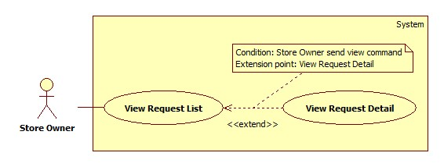

Figure 3: 1.1.1.2. <Store Owner> View Request Detail

Use Case Specification

|  |  |  |  |
| --- | --- | --- | --- |
| **USE CASE – View Request Detail** | | | |
| **Use Case No.** | Click here to enter text. | Use Case Version | 2.0 |
| **Use Case Name** | View Request Detail | | |
| **Author** | PhucTQ | | |
| **Date** | May 29, 2015 | Priority | High |
| **Actor**:   * Store Owner.   **Summary**:   * System display detail information include status of consignment request to Store Owner.   **Goal**:   * Store Owner view detail information of consignment request.   **Triggers**:   * Store Owner asks the system to show request detail   **Preconditions**:   * Store Owner has logged onto the system.   **Post Conditions**:   * **Success**: Detail information of consignment request is shown. * **Fail**: Detail information of consignment request is not shown.   **Main Success Scenario**:   |  |  |  | | --- | --- | --- | | Step | Actor Action | System Response | | 1 | Store Owner asks the system to show detail information of a consignment request. | Show consignment request detail include following information:   * Product Name * Product Image * Product Description * Request Date * Consign Price * Transfer Date * Consignment Status |   **Relationships**:   * Included Use-case: N/A. * Extended Use-case: View Request List. * Including Use-case: N/A. * Extending Use-case: N/A.   **Business Rules**:   * Product’s information is displayed clearly for Store Owner to view. | | | |

##### <Store Owner> Normal Accept Request

Use Case Diagram

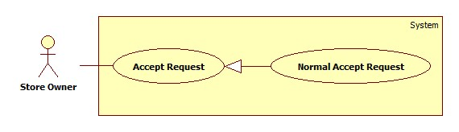

Figure 3: <Store Owner> Normal Accept Request

Use Case Specification

|  |  |  |  |
| --- | --- | --- | --- |
| **USE CASE – Normal Accept Request** | | | |
| **Use Case No.** | Click here to enter text. | Use Case Version | 2.0 |
| **Use Case Name** | Normal Accept Request | | |
| **Author** | PhucTQ | | |
| **Date** | May 30, 2015 | Priority | High |
| **Actor**:   * Store Owner.   **Summary**:   * This use case allow Store Owner accept consignment request after the product is evaluated by pricing service.   **Goal**:   * Store Owner accept consignment request.   **Triggers**:   * Store Owner asks the system to accept a consignment request.   **Preconditions**:   * Store Owner has logged onto the system. * The consignment product’s price has been evaluated. * The consignment has not been accepted or refused by Store Owner. * The consignment has not been cancelled by Customer.   **Post Conditions**:   * **Success**: The consignment has been accepted. Product is now available to be public on web. * **Fail**: The consignment has not been accepted.   **Main Success Scenario**:   |  |  |  | | --- | --- | --- | | Step | Actor Action | System Response | | 1 | Ask the system to accept a consignment. | Show information:   * Consign Price label * Accept command * Close command | | 2 | Send Accept command  [Alternative 1] | Show message: “Accepted successfully”.  [Exception 1] |   **Alternative Scenario**:   |  |  |  | | --- | --- | --- | | No | Actor Action | System Response | | 1 | Send Close command | Close information.  Return to previous view. |   **Exceptions**:   |  |  |  | | --- | --- | --- | | No | Actor Action | System Response | | 1 |  | Show fail message: “Accepted Fail”. |   **Relationships**:   * Included Use-cases: N/A * Extended Use-case: N/A * Including Use-case: N/A * Extending Use-case: N/A   **Business Rules**:   * Consign price was evaluated in use case **Consign product**. * After accept successful, product’s status shall be changed from Not Available to In Inventory, and product shall be moved to inventory. * System shall notify customer after consignment is accepted. * Store Owner shall be able to cancel accepted-consignment until midnight of the seventh day after accept. | | | |

##### <Store Owner> Accept Request and Set Price

Use Case Diagram

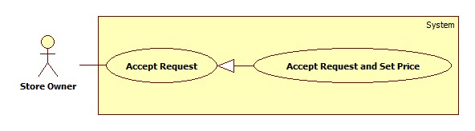

Figure 3: <Store Owner> Accept Request and Set Price

Use Case Specification

|  |  |  |  |
| --- | --- | --- | --- |
| **USE CASE –** Accept Request and Set Price | | | |
| **Use Case No.** | Click here to enter text. | Use Case Version | 2.0 |
| **Use Case Name** | Accept Request and Set Price | | |
| **Author** | PhucTQ | | |
| **Date** | May 30, 2015 | Priority | High |
| **Actor**:   * Store Owner.   **Summary**:   * This use allow Store Owner accept consignment request while product cannot be evaluated by pricing service.   **Goal**:   * Store Owner accept consignment request.   **Triggers**:   * Store Owner asks the system to accept a consignment request.   **Preconditions**:   * Store Owner has logged onto the system. * The consignment product’s price has **not** been evaluated. * The consignment has not been accepted or refused by Store Owner. * The consignment has not been cancelled by Customer.   **Post Conditions**:   * **Success**: The consignment has been accepted and consign price has been set. Product is now available to be public on web. * **Fail**: The consignment has not been accepted.   **Main Success Scenario**:   |  |  |  | | --- | --- | --- | | Step | Actor Action | System Response | | 1 | Asks the system to accept a consignment request. | Show information:   * Consign Price free text field * Accept command * Close command | | 2 | Enter consign price.  Send Accept command.  [Alternative 1] | Show successful message: “Accepted successfully”.  [Exception 1, 2] |   **Alternative Scenario**:   |  |  |  | | --- | --- | --- | | No | Actor Action | System Response | | 1 | Send Close command. | Close information dialog box  Return to previous view. |   **Exceptions**:   |  |  |  | | --- | --- | --- | | No | Actor Action | System Response | | 1 |  | Show fail message: “Accepted Fail”. | | 2 | Enter wrong number format | Show message: “Wrong number format”. |   **Relationships**:   * Included Use-cases: N/A * Extended Use-case: N/A * Including Use-case: N/A * Extending Use-case: N/A   **Business Rules**:   * Consign Product is evaluated by Store Owner. * After accept successful, product’s status shall be changed from Not Available to In Inventory, and product shall be moved to inventory. * System shall notify customer after consignment is accepted. * Store Owner shall be able to cancel accepted-consignment until midnight of the seventh day after accept. | | | |

##### <Store Owner> Refuse Request

Use Case Diagram

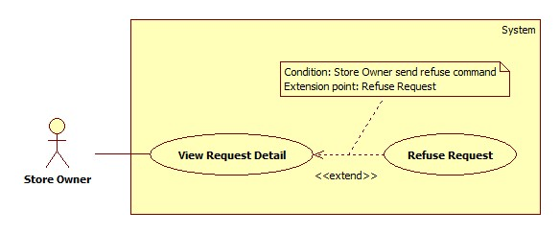

Figure 3: <Store Owner> Refuse Request

Use Case Specification

|  |  |  |  |
| --- | --- | --- | --- |
| **USE CASE –** Refuse Request | | | |
| **Use Case No.** | Click here to enter text. | Use Case Version | 2.0 |
| **Use Case Name** | Refuse Request | | |
| **Author** | PhucTQ | | |
| **Date** | May 30, 2015 | Priority | High |
| **Actor**:   * Store Owner.   **Summary**:   * This use case allow Store Owner refuse consignment request.   **Goal**:   * Store Owner refuses consignment request.   **Triggers**:   * Store Owner asks the system to refuse a consignment request.   **Preconditions**:   * Store Owner has logged onto the system. * The consignment has not been accepted or refused by Store Owner. * The consignment has not been cancelled by Customer.   **Post Conditions**:   * **Success**: The consignment has been refused. * **Fail**: The consignment has not been refused.   **Main Success Scenario**:   |  |  |  | | --- | --- | --- | | Step | Actor Action | System Response | | 1 | Asks the system to refuse a consignment. | Show information:   * Confirm message * Refuse command * Close command | | 2 | Send refuse command.  [Alternative 1] | Show successful message: “Refused successfully”.  [Exception 1] |   **Alternative Scenario**:   |  |  |  | | --- | --- | --- | | No | Actor Action | System Response | | 1 | Click “Close” button. | Close information dialog box.  Return to request detail page. |   **Exceptions**:   |  |  |  | | --- | --- | --- | | No | Actor Action | System Response | | 1 |  | Show fail message: “Refused Fail”. |   **Relationships**:   * Included Use-cases: N/A. * Extended Use-case: View Request Detail. * Including Use-case: N/A. * Extending Use-case: N/A.   **Business Rules**:   * System shall notify customer after consignment is refused. * After refuse successfully, product changes status from Not Available to Refused. * Store Owner shall be able to cancel refused-consignment until midnight of the seventh day after refuse. | | | |